Project #4: Interpret Data

Report

Camdin Wagner McGuigan, Nay Law Htoo, Ahmad Rezaie
Department of Civil & Environmental Engineering, University of Nebraska-Lincoln
CIVE 202: Civil Engineering Analysis II
Dr. Kaycie Lane
April 21, 2026

Table of Contents
Project #4: Interpret Data 1
Report 1
Introduction/Background 3
Methods 3
Method 1: Acquire Data 3
Method 2: Data Integration & Joining 3
Method 3: Data Processing 3
Method 4: Risk Modeling 4
Method 5: Sensitivity & Plotting Analysis 4
Results & Discussion 4
Comparison of Risk Definition & Ethical Implications 4
Comparison of NRI vs. Proposed Risk Results & Funding Implications 5
Discussion of the Map Results 5
Wyoming: National Risk Index Score 6
Montana: National Risk Index Score 7
Wyoming: Custom Risk Score 8
Montana: Custom Risk Score 9
Specific Risk Wildfire Example 10
References 11

Introduction/Background
Risk Averse LLC has been commissioned to conduct a comprehensive sensitivity analysis of the Federal Emergency Management Agency’s (FEMA) National Risk Index (NRI). The NRI is a crucial tool for the Department of Homeland Security, as it quantifies natural disaster risk across the United States and directly influences federal resource allocation and disaster management strategies. However, the reliance on a specific multiplicative scoring methodology, combining Expected Annual Loss (EAL), Social Vulnerability (SOVI), and Community Resilience (RESL), may introduce "categorical bias" that affects how different communities are prioritized.
This project specifically examines the impact of these scores within the states of Montana and Wyoming at the Census tract level. By utilizing Python to integrate the NRI and CDC Social Vulnerability Index (SVI) datasets, the research team will develop an alternative, weighted definition of risk to compare against the standard NRI rankings. The goal of this study is to determine how varying risk inputs affect community evaluations, providing Risk Averse LLC with an evidence-based assessment of potential biases that could impact future disaster mitigation funding and policy decisions.

Methods

Method 1: Acquire Data
The technical execution began with the implementation of a Python-based environment using the Pandas library for high-level data manipulation, GeoPandas for processing geospatial vector data, and Matplotlib for creating static visualizations. To ensure a comprehensive analysis of the target regions, we imported five primary data assets: the FEMA National Risk Index (NRI) Census Tract tables for Wyoming and Montana, the corresponding CDC Social Vulnerability Index (SVI) datasets for both states, and the NRI Data Dictionary for variable clarification. This multi-source approach provided the necessary raw data to evaluate both physical hazard risks and socio-economic vulnerabilities across all target census tracts.

Method 2: Data Integration & Joining
A critical phase of the methodology involved standardizing the joining to ensure a seamless merge between the FEMA and CDC datasets. Since FIPS codes often vary in format across different sources, a unified TRACTFIPS field was created for each dataset. This was achieved through a process of string conversion, the removal of decimal remainders using .replace(".0", ""), and applying .zfill(11) to pad the codes to a standardized 11-digit length. Once the keys were synchronized, a Left Join was executed on the TRACTFIPS column. This effectively linked the socio-economic SVI data with the primary NRI hazard data, resulting in a unified relational database for each state.

Method 3: Data Processing
After the initial join, the data underwent a thorough pre-processing phase to prepare it for comparative analysis. We added unique state identifiers using a new column called STATE_NAME to maintain data provenance. Then, we utilized pd.concat to merge the Wyoming and Montana DataFrames into a single master file. To meet the client's requirement for addressing incomplete data, our team conducted an audit for null values across the core metrics: Risk, Expected Annual Loss (EAL), Social Vulnerability (SOVI), and Community Resilience (RESL). We addressed all identified missing or "NA" values through zero-imputation using the .fillna(0) method, ensuring that calculations remain numerically stable throughout the study area.

Method 4: Risk Modeling
To conduct the necessary sensitivity analysis, the team developed a custom Weighted Additive Model intended to address potential biases in the standard NRI (National Risk Index) multiplicative model. This formula assigns specific weights to the normalized inputs as follows: (0.50 * EAL) + (0.35 * SOVI) + (0.15 * (100 - RESL)). By changing the mathematical relationship from a product to a weighted sum, the model examines how prioritizing physical economic loss (EAL) at 50% affects the ranking of communities compared to the official FEMA scores. This alternative methodology enables Risk Averse LLC to determine whether the standard NRI multiplier disproportionately obscures risk in areas with lower property values but higher social vulnerability.

Method 5: Sensitivity & Plotting Analysis
To effectively communicate the findings, the calculated scores were projected onto a geographic coordinate system using GeoPandas, alongside a state-level Census tract shapefile. The mapping process involved merging the calculated risk data with the spatial geometries and filtering out any empty or invalid shapes to ensure visual accuracy. The analysis specifically focused on Wildfire Risk as a key representative hazard for the region. This resulted in the creation of bar charts to compare state-level averages, as well as dual choropleth maps. These maps enable a direct side-by-side comparison between the official National Risk Index (NRI) scores and the custom additive model, highlighting geographic "hotspots" where the two methodologies differ in assessing community risk.

Results & Discussion

Comparison of Risk Definition & Ethical Implications
The key distinction between the FEMA National Risk Index (NRI) and the custom definition created for Risk Averse, LLC, is their approach to integrating physical loss and social factors. The NRI uses a multiplicative model, calculating risk as the product of Expected Annual Loss (EAL) and a "Social Factor," which combines Social Vulnerability divided by Community Resilience. This model can lead to high-risk scores from minimal physical loss if social vulnerability is extreme.
Conversely, our custom model employs a weighted additive approach:
Risk = (0.50 * EAL) + (0.35 * SOVI) + (0.15 * [100 - RESL])]
This model assigns set weights to economic loss and social vulnerability, preventing social factors from disproportionately affecting the risk assessment. These differing methodologies create distinct biases. The NRI may foster a "wealth bias," favoring high property value areas in risk rankings, which can obscure the needs of lower-income, rural communities with higher vulnerability. Our model addresses this issue by capping EAL's influence and emphasizing the "Resilience Deficit." For states and communities, these differences have significant policy implications. Using the NRI might lead Wyoming to prioritize infrastructure in high-value areas, while our model encourages a "people-first" approach, focusing on funding social services in vulnerable communities. These findings highlight the need for better data collection on "intangible losses," such as cultural heritage and ecosystem services. Methodological choices in risk assessment impact FEMA funding allocations, raising important questions about equity in federal disaster assistance.

Comparison of NRI vs. Proposed Risk Results & Funding Implications
The analysis of the FEMA National Risk Index (NRI) and the proposed additive risk model reveals important changes in measuring vulnerability in Montana and Wyoming. The current NRI uses a multiplicative approach, which often results in "risk hotspots" in areas with high property values, as it heavily weighs Expected Annual Loss (EAL). The proposed additive model linearizes these relationships. By giving 35% weight to Social Vulnerability (SOVI), this model emphasizes the risk in rural and lower-income areas that may lack high-value infrastructure but have vulnerable populations with limited recovery capacity.
As it stands, residents in low-property-value rural areas may be classified as "Low Risk" despite facing greater recovery challenges due to socioeconomic barriers. This could lead to exclusion from vital pre-disaster mitigation grants, like the Building Resilient Infrastructure and Communities (BRIC) program. Consequently, communities in need may be overlooked simply because of their lower real estate values.
Shifting to a more equitable, additive definition of risk can ensure federal funding is more fairly distributed. By prioritizing high-vulnerability individuals over high-value assets, the proposed model promotes a "people-first" disaster management approach. For Montana and Wyoming policymakers, adopting this method means justifying broader resource allocation to rural areas, ultimately providing essential support for all citizens, regardless of their community’s economic standing.

Discussion of the Map Results
The NRI maps (Maps 1 and 2) focus on economic preservation, whereas the Custom Risk maps (Maps 3 and 4) emphasize human vulnerability. The distinction between these maps reveals forgotten tracts, areas where people are highly vulnerable, but where property values are not high enough to result in a significant FEMA score.

Wyoming: National Risk Index Score
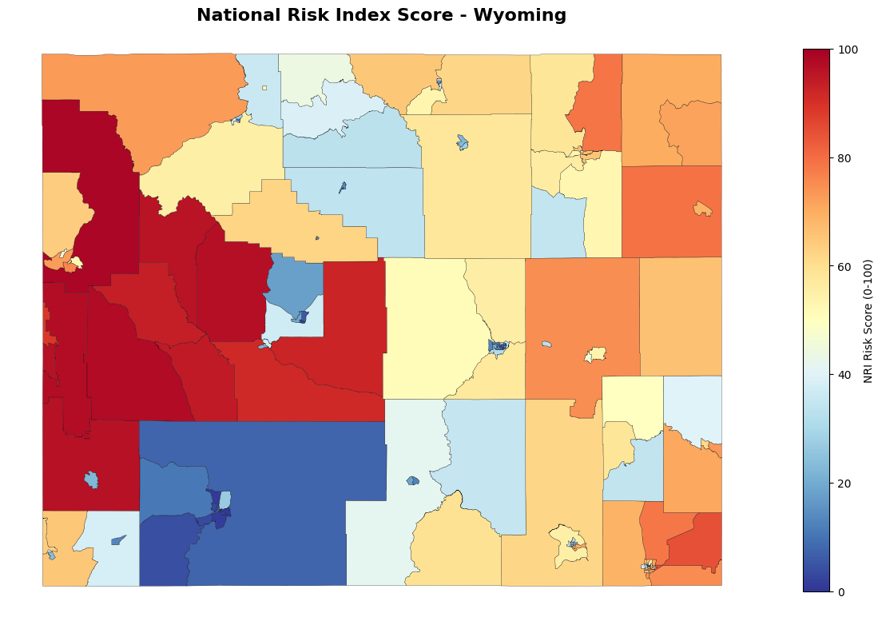
Figure 1- Map 1

Montana: National Risk Index Score
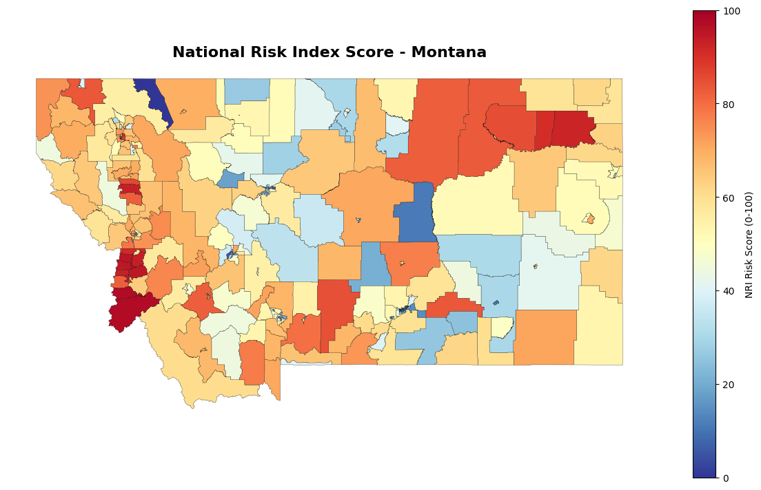
Figure 2 - Map 2

Wyoming: Custom Risk Score
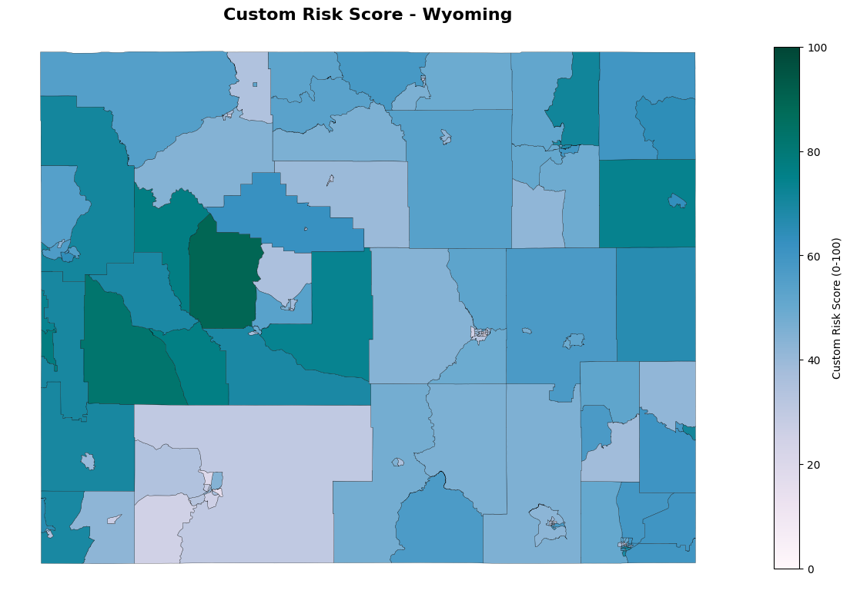
Figure 3 -Map 3

Montana: Custom Risk Score
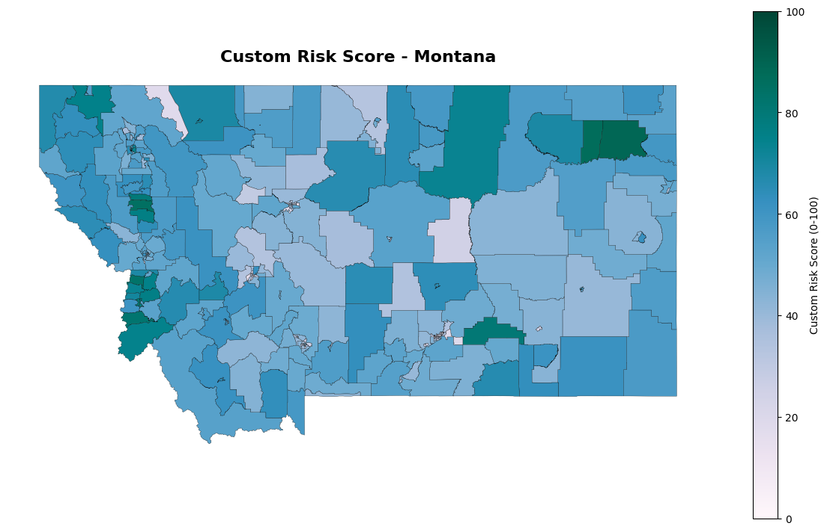
Figure 4 - Map 4

Specific Risk Wildfire Example
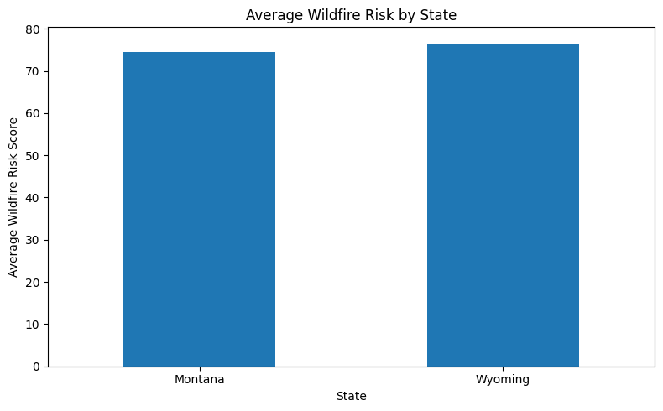
Figure 5 - Chart 1

References
Dataset: Federal Emergency Management Agency. (2025). National Risk Index: Census Tract Layer (Montana & Wyoming) [Data set]. U.S. Department of Homeland Security. https://hazards.fema.gov/nri/data-resources
Technical Manual: Federal Emergency Management Agency. (2025). The National Risk Index: Technical Documentation. U.S. Department of Homeland Security. https://hazards.fema.gov/nri/understanding-scores-ratings
Dataset: Centers for Disease Control and Prevention / Agency for Toxic Substances and Disease Registry. (2022). Social Vulnerability Index: 2022 Database Montana & Wyoming [Data set]. U.S. Department of Health and Human Services. https://www.atsdr.cdc.gov/place-health/php/svi/svi-data-documentation-download.html
Methodology: Agency for Toxic Substances and Disease Registry. (2022). SVI Methods: Calculation of the Social Vulnerability Index. https://www.atsdr.cdc.gov/place-health/php/svi/index.html

